Team pLANer

Elaboration Deliverable

Alex Hunt

Brendan Ashby

Jon Skurka

Michael Casper

Contents
Domain Model Diagram 3
Supplemental Specification 4
Deployment Diagram 5
Use Cases 6
Listing 6
Details 6
Work Breakdown Structure 10
Project Schedule 11
Contributions Summary 11
Status Report 12

Domain Model Diagram
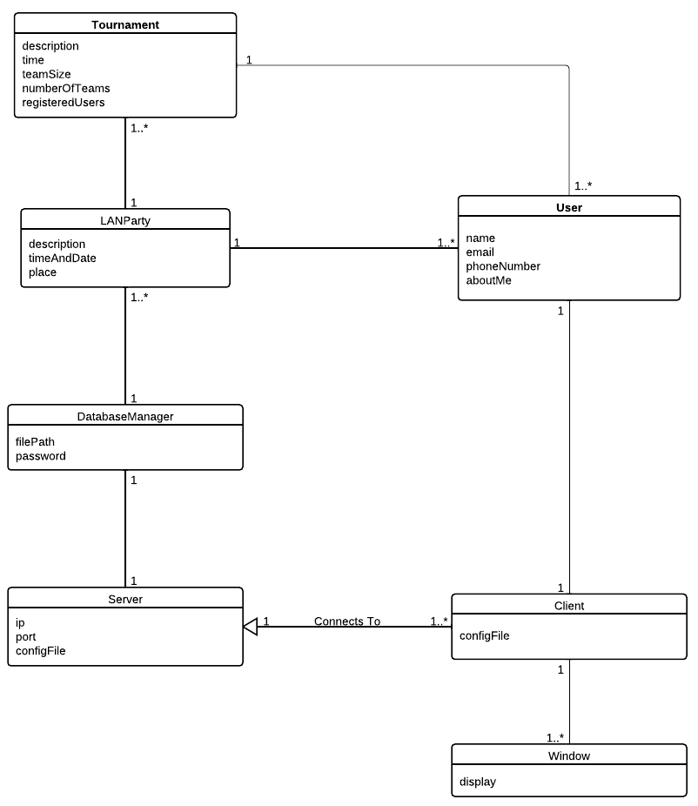

Supplemental Specification

Requirement No. | Description | Priority
FR1 | The system should allow users to securely login | M
FR2 | The server should maintain a seperate connection with up to 1,000 clients | M
FR3 | The system should generate tournament brackets for a given number of players | M
FR4 | The system should support a user database with stored personal settings and encrypted passwords | M
FR5 | The system should alert users of upcoming tournaments. | S
FR6 | The System should support SSL | S
FR7 | The system should support reporting the outcome of tournament matches. | M
FR8 | The system should schedule tournaments to allow people to play in the most LAN games without conflicts | C
FR9 | The system should support the ability for administrators to create tournament matches | M
FR10 | The system should overlay LAN party locations on a map using the Google Maps api | C

Requirement No. | Description | Priority
NFR1 | Easy to use with effective and intuitive UI. | M
NFR2 | system should make accurate modifications to the database and maintain the databases consistency at all times. | M
NFR3 | The system should maintain a seamless, lag-free connection between the clients and server. | M

*MoSCoW priority scheme is followed.
FR- List of functional requirements.
NFR- List of non functional requirements.

Deployment Diagram
We have a client GUI written in python GTK+ that connects to a server written in python, which connects to a SQLite database and makes the appropriate modifications.
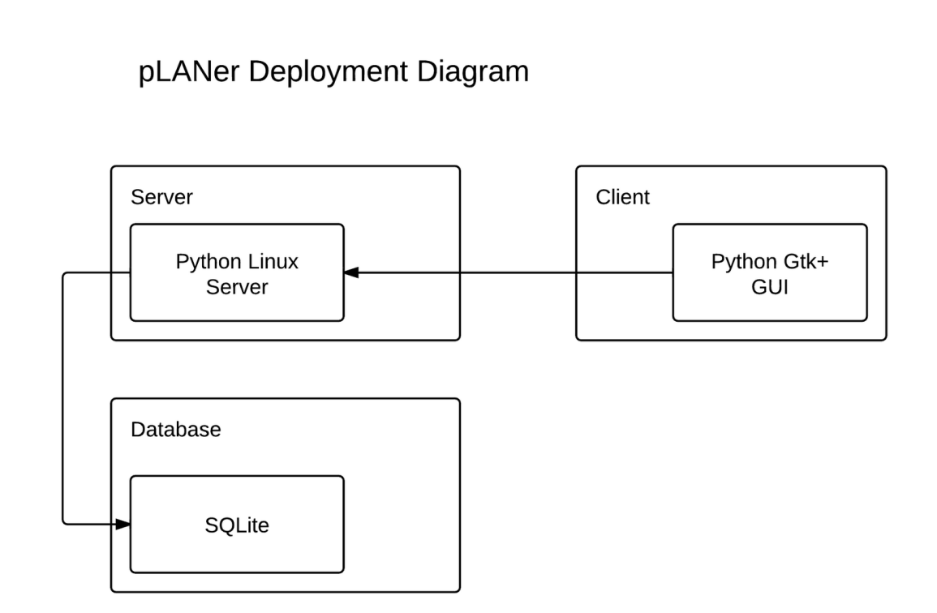

Use Cases

Listing
UC1 | Register
UC2 | Login
UC3 | LAN Party Creation
UC4 | Create a Tournament for a LAN Party
UC5 | Register For LAN Party
UC6 | Register for Tournament for a LAN Party
UC7 | User Claims a Win in a Tournament

Details
Use Case | Register
Identifier | UC1
Description | This use case models a user registering an account with the server to grant him or her access to the LAN party information from that server.
Actors | User
Pre-Conditions | None
Flow of Events | - The use case starts when a user launches the pLANer application.  - The system prompts the user with a login screen with Login and Register options.  - The user clicks the Register button.  - The system prompts the user with a form in which to fill out required registration information.  - The user fills in his or her desired username, password, password confirmation, email, and an optional phone number.  - The user presses Register.  - If the registration is valid,  7.1 The system notifies the user that they have been successfully registered.  7.2 The user is returned to the login screen.  Else  7A The user is notified that the registration failed and to try again.  7B The system returns to step 5.
Post-Conditions | - The user is registered in the system’s database.  - An email is sent to the user confirming registration.

Use Case | Login
Identifier | UC2
Description | This use case models a user or admin logging in to the system.
Actors | User
Pre-Conditions | - User is registered in the server’s database.
Flow of Events | - The use case begins when a user launches the pLANer application.  - The system prompts the user for a username and password.  - The user types his or her username.  - The user presses Tab to advance to the password field.  - The user enters his or her password.  - The user presses Login.  - The system displays the progress in connecting to the server and authenticating the account.  - If the authentication succeeds  8.1 The system indicates that the login was successful and takes the user to the main window.  Else  8A The system indicates that the username or password were incorrect.  8B The user is returned to the login screen.
Post-Conditions | - User has a persistent connection to the server on his or her account (I.E. They are “logged in”)..

Use Case | LAN Party Creation
Identifier | UC3
Description | This use case models an admin creating a new LAN party.
Actors | Admin
Pre-Conditions | - The admin is logged in.  - The system is currently displaying the main window.
Flow of Events | - The admin clicks the File menu.  - The system shows a dropdown menu below the File menu option.  - The admin clicks Create New LAN Party from the File menu dropdown.  - The system displays a new window showing the available options for a LAN party.  - The admin enters the name, date and time, place, and description of the LAN party.  - The admin then presses Create.  - The system responds saying the LAN Party has been successfully created and returns the admin to the main window.
Post-Conditions | - The new LAN party is now in the system’s database.  - The LAN party should be displayed in the list of the main window.

Use Case | Create a Tournament for a LAN Party
Identifier | UC4
Description | This use case models an admin adding a tournament to an existing LAN party in the system’s database.
Actors | Admin
Pre-Conditions | - The admin is logged in.  - The system is displaying the main window.  - A LAN party already exists in the database.
Flow of Events | - The admin right clicks the existing LAN party.  - The system displays a context menu with available options  - The admin selects Add New Tournament  - The system displays a new window to the user with a form requesting information about the tournament.  - The admin enters the tournament’s name, time, number of teams, team size, and description.  - The admin presses Add  - The system returns to the main window and the tournament is now listed in the LAN party’s list of tournaments.
Post-Conditions | - A new tournament is created under the existing LAN party in the system’s database.  - The system is displaying the main window.

Use Case | Register for LAN Party
Identifier | UC5
Description | This use case models a user registering for a LAN party.
Actors | User
Pre-Conditions | - The user is logged in.  - The system is displaying the main window.  - A LAN party exists in the main window’s list.
Flow of Events | - The user right clicks on the LAN party in the list he or she desires to attend.  - The system displays a context menu with available options.  - The user selects Register  - The system displays a confirmation to the user informing him or her that they are registered for the LAN party.
Post-Conditions | - The user is registered in the system’s database for the selected LAN party.

Use Case | Register for Tournament in a LAN Party.
Identifier | UC6
Description | This use case models a user registering for a tournament in a LAN party.
Actors | User
Pre-Conditions | - The user is logged in.  - The system is displaying the main window.  - A LAN party exists in the main window’s list.
Flow of Events | - The user right clicks on the LAN party in the list he or she desires to attend.  - The system displays a context menu with available options.  - The user selects More Information  - The system displays a new window to the user with all the information about the selected LAN party.  - The user selects the corresponding Register button next to the tournament he or she would like to register for.  - The system now displays Registered instead of a Register button next to that tournament and updates the registered players count on the UI.
Post-Conditions | - The user is registered in the system’s database for the selected tournament.

Use Case | User Claims a Win in a Tournament
Identifier | UC7
Description | This use case models how a user would claim to have won a match in a tournament.
Actors | User
Pre-Conditions | - User is logged in.  - System is at the main window.  - A LAN party exists in the main window’s list.  - A tournament exists in the Lan party’s list of tournaments.
Flow of Events | - The user right clicks on the LAN party in the list he or she desires to attend.  - The system displays a context menu with available options.  - The user selects More Information  - The system displays a new window to the user with all the information about the selected LAN party.  - The user clicks View Tournament Bracket for the desired tournament.  - The system shows the tournament bracket for that tournament.  - The user clicks the I Won button next to his or her name in the tournament bracket.  - The system replaces the I Win and I Lost buttons with the text Won
Post-Conditions | - System has the user’s win claim stored in its database.

Work Breakdown Structure
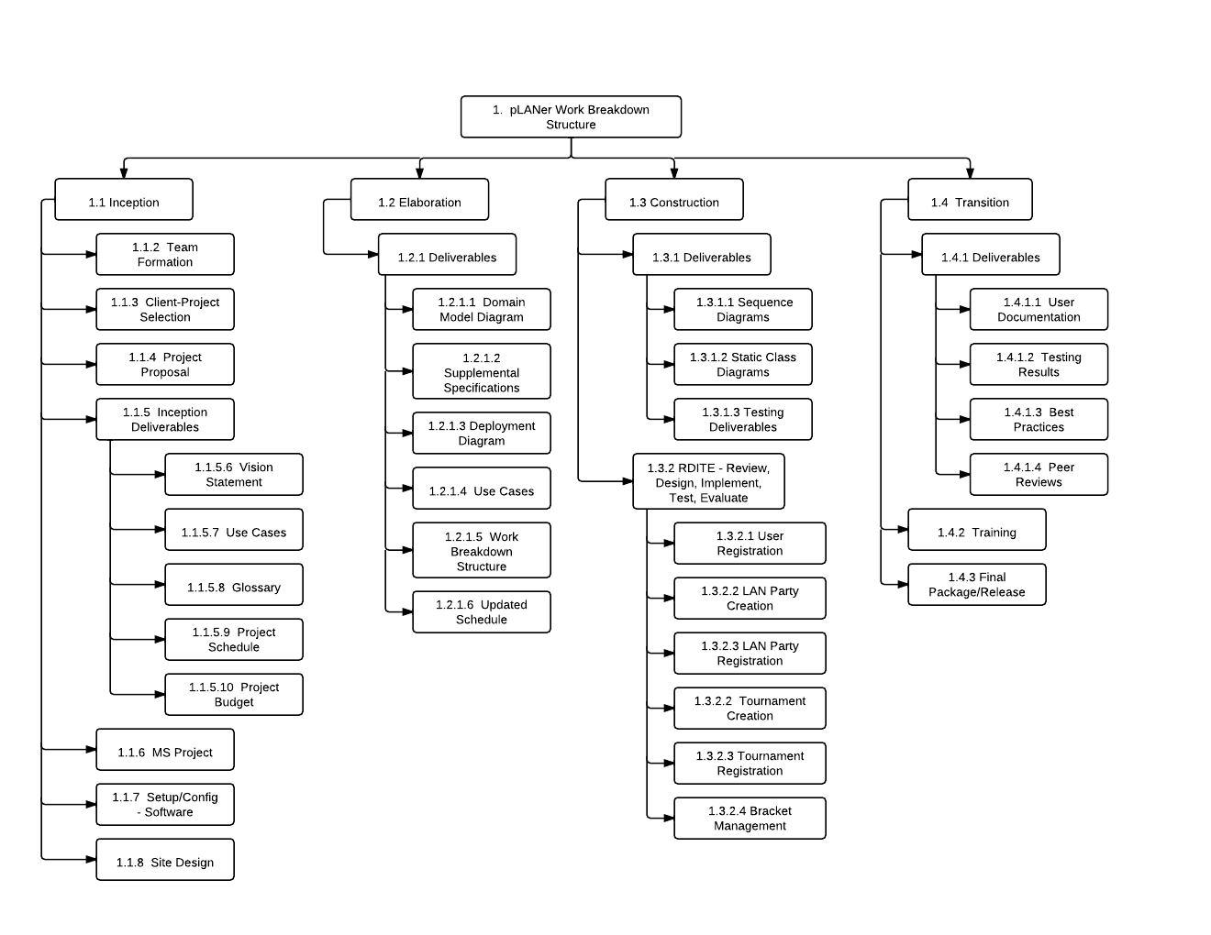

Project Schedule

Iteration 1: (October 3rd to 16th)
A rapid GUI implementation, with basic login and register functionality.
The front end needs methods to send client user name hashes for a secure login handshake.
Basic GUI object created to display login screen, no advanced styling at first.
For back end, a simple way to send receive login hashes and new user information

Iteration 2: (October 17th to 30th)
Implement initial core bracket management mechanic.
Provide a front end layout for currently running events, center on a method to enter contestant data and get back basic brackets.
Get a basic skeleton of the full GUI working.
Get database communication established with SQLite and save initial data including Username, Salted Password Hashes, emails, and phone numbers.

Iteration 3: (October 31st to November 13th)
Admin can schedule LAN party
Users can view and register for scheduled LAN parties and tournaments.
Users can view tournament brackets.
Admin can add and edit tournaments with all information.

Iteration 4: (November 14th to 27th)
Send users notifications for when their games are going to start via texting, email and a desktop notification.
Full tournament bracket viewing and updating.
Verify all critical bugs are fixed.
Deploy the application.

Contributions Summary
Alex Hunt worked on the use cases, updating the schedule, and the domain model diagram for the elaboration deliverable.

Jonathan Skurka worked on the Supplemental Specifications and the project schedule.

Michael Casper worked on the Deployment Diagram, the Work Breakdown Structure, and Supplemental Specifications.

Brendan Ashby worked on the Use Cases and finalizing the document.

Status Report

What did we do this week?
- Elaboration Deliverable
- Completed Iteration 1
- Demo! (Screenshots from the demo shown below)

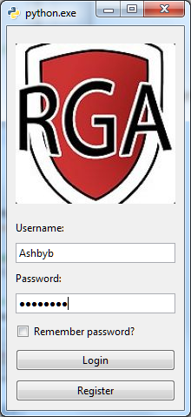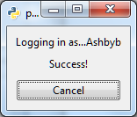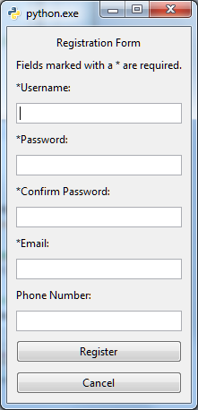

What are the impediments or risks?
- None so far this week

What are our plans for next week?
- Work on iteration 2
  - Start implementing GUI
  - Start writing database code
  - Start implementing the bracket viewer

